Contributor: Olivia Wolf

**Taller de Arte Mural**

Active: 1945-1946—Buenos Aires, Argentina

The Taller de Arte Mural (Mural Art Workshop) was founded in 1945 by a group of leading Argentine-based artists with a common vision of promoting muralism as a nation-wide public art program. The workshop was comprised of Antonio Berni (Born: 1905–Rosario; Died: 1981–Buenos Aires), Juan Carlos Castagnino (Born: 1908– Mar del Plata; Died: 1972– Buenos Aires), Manuel Colmiero Guimaraes (Born: 1901– Pontevedra, Galicia, Spain; Died: 1991–Salvaterra de Miño, Galicia, Spain), Lino Enea Spilimbergo (Born: 1896 –Buenos Aires; Died: 1964–Unquillo, Córdoba, Argentina), and Demetrio Urruchúa (Born: 1902—Pehuajó, Argentina; Died: 1978–Buenos Aires). Together, these artists collaborated to produce the renowned murals of the Galerías Pacífico in Buenos Aires.

The Taller de Arte Mural formed incrementally, after several periods of early artistic collaboration. Key members of the group were first brought together to work for Mexican muralist David Alfaro Siquieros during his visit to Argentina in 1933. At this time, Siquieros and his fellow Mexican muralists, José Orozco and Diego Rivera, were known for their murals and public advocacy of the genre as an anti-bourgoise art form for the masses. Siquieros was invited to give two lectures in Buenos Aires on Mexican muralism for the Friends of Art Society— later the site of the Van Riel Gallery. While in Argentina, Siquieros received a private mural commission win the nearby town of Don Torcuato from newspaper baron, Natalio Botana, owner of *La Crítica.* To execute the mural, Siquieros constructed a team of Argentine artists that included Antonio Berni, Juan Carlos Castangino, and Lino Enea Spilimbergo. Known as *Ejercicio Plástico* [Plastic Exercise], the mural was crafted along with a technical and theoretical manifesto by the same name.

[For a 3-D virtual gallery of *Ejercicio Plástico* mural, please see:

http://www.museobicentenario.gob.ar/360/siqueiros-flash/mural360.html ]

Shortly after the completion of the piece and its manifesto, Berni critiqued Siquieros for lauding muralism as the only anti-bourgeoise art form while executing *Plastic Exercise* as a private commission. Berni began experimenting independently with a new form of moveable mural painting in 1934, considered *mural sobre tela*— murals on cloth. Major examples of these large-scale works include *Desocupados* (218 x 300cm), *Chacareros* (200x 300 cm) and *Manifestacion* (183 x 247 cm). These pieces are characterized by their social realism, sharply criticizing the impoverished state of the Argentine people.

[For an image of *Desocupados* and other works by Berni from this period*,* please see: http://museografo.com/el-realismo-critico-de-antonio-berni/]

In 1943, Berni was reunited with Castagnino and Urruchúa when the *Sociedad Hebraica Argentina* (Hebrew Society of Argentina) selected their designs in a competition to decorate its community center. This marked a second major phase of collaboration between the artists that would later form the Taller de Arte Mural.[1] While the *Sociedad Hebraica Argentina* murals were all executed by these artists independently in different locations within the building, they were ideologically linked by an emphasis on cultural themes, such as *Literatura, Artes Plásticas, Musica.* (Literature, The Arts, Music) and *El libro y las Ciencias* (The Book and The Sciences). The artists chose to emphasize cultural themes in their panels because they felt that without ideological content focused on collective values, muralism degenerates into decadence.

In 1945, Urruchúa, Berni, Castagnino, Colmiero and Spilimbergo officially formed the Taller de Arte Mural, fueled by a shared vision of initiating a large-scale popular mural program that would enable the everyday person to encounter art in the public sphere. In many ways, the artist’s united stance was a direct criticism of Siquiero’s *Ejercicio Plástico*, which they ultimately condemned as a private commission devoid of cultural value, and thereby betraying muralism’ highest calling as ideological public art. The Taller sought the support of the state, so that they might execute projects in well-known public buildings. The group was established within the political context of Peron’s first tenure, and at the end of the World War II. The group’s main preoccupation was to reach the masses via muralism.

The ideals and aesthetics of the Taller Arte Mural are exemplified by their first and only truly collaborative mural cycle, gracing the cupola of the Galerías Pacífico in Buenos Aires. However, unrealized projects for the railway station of Retiro and the Law School of the University of Buenos Aires were also considered at one point. The Galerías Pacífico is located in the Argentine Bon Marché building in Buenos Aires’ financial district, and was originally designed by Emilio Cornelio Agrelo as a grand department store. The structure served as a tearoom, shopping mall, auditorium and apartments. In 1896, the Beaux Arts Museum was installed within the building, and in 1910, began exhibiting works by Argentine artists Schiaffino, Sívori, Della Valle, and Malharro, among others. The site also became the location for the National Beaux Arts Academy, and was purchased by the Buenos Ayres & Pacific Railway Company Limited (now the General San Martín Railway) for the installation of its central offices.[2] The original building was open to the sky, but a roof and cupola were added by the architects, Aslán and Escurra, in 1946. The Taller de Arte Mural was offered the task of painting the cupola.

[For a Virtual map of the Galerias Pacifico murals*,* [http://www.galeriaspacifico.com.ar/eng/arte.php#](http://www.galeriaspacifico.com.ar/eng/arte.php)]

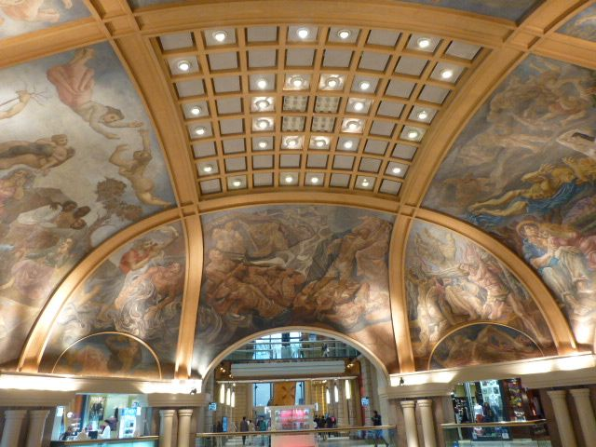

Taller de Arte Mural, 1946. Galerías Pacífico. Central panel shows Spilimbergo’s, *El dominio de las fuerzas natural* (The dominion of natural forces), Fresco.1946. Galerías Pacífico. Photo credit: Caroline Olivia Wolf.

The work displays unified conceptual and compositional themes across the various panels of the cupola. The project began as a plaster model one and a half diameter in size, carefully constructed with a geometric plan in Urruchúa’s studio on at 1770 Carlos Calvo street. Each artist was responsible for distinct sections of the composition, which overall was dedicated to themes associated with the foundation of Argentine culture. Overall, the mural cycle is characterized by a particular vein of social realism, which Berni would dub “New Realism.”

Antonio Berni’s panel for the Galerías Pacífico, *El Amor* [Love] or *La germinación de la tierra* [The germination of the land], is dedicated to the theme of love and/or national production. It displays bucolic imagery of European migrant women embraced by criollo farmers and agricultural labor, subtly alluding to racial mecegenation brought about by immigration and colonization of the Argentine pampas.

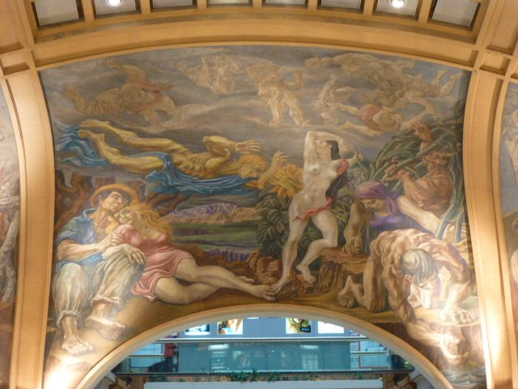

Antonio Berni in collaboration with Taller de Arte Mural, *El Amor* [Love] or *La germinación de la tierra* [The germination of the land]. Fresco.1946. Galerías Pacífico. Photo credit: Caroline Olivia Wolf.

Castagnino’s panel, *La vida doméstica* [Domestic Life] or *La ofrenda generosa de la Naturaleza* [Nature’s Generous Offering], is distinguished by a lyrical style that draws heavily from Greco-Roman fresco traditions and palettes. The panel is marked by the artist’s characteristic interest in imagery of maternity and horses. Castagnino would go on to an international career, producing a series of murals in Rome in 1965 and exhibiting in Paris, Montevideo, New York, Rio de Janeiro and Saigon among other locations. Maria Cristina Servienti described this panel as “the celebration of a utopic harmony between human beings and natural fertility.”[3]

Colmeiro’s panel, titled *La Pareja Humana* [The Human Couple] or *El amor maternal* [Maternal Love], again reflects the national concern for population, harkening back to Alberdi’s famous quote “To govern is to populate.” Colmeiro’s linear, geometric forms draw upon biblical Adam and Eve iconography, while isolated male and female figures in the lunettes and a reclining couple sprouting leaves borrow from Greco-Roman mythology.

Spilimbergo’s *El dominio de las fuerzas natural* (The dominion of natural forces), heroizes the common worker, depicting monumental peasants and fishermen. Demetrio Urruchúa also contributed to the work.

The figures in Urruchúa’s *La fraternidad* (Fraternity) panel are characterized by their geometric form, and a theme of racial harmony is clearly conveyed by the interacting black, white and Asian figures engaged before a stark landscape. Critic Rafael Squirru described the Pacific arcade frescos as drawing upon Greco-Roman aesthetics, while reflecting American concerns. The figures within the cycle, while depicting everyday figures such as farmers and sailors, draw upon a monumental classical heroic tradition.

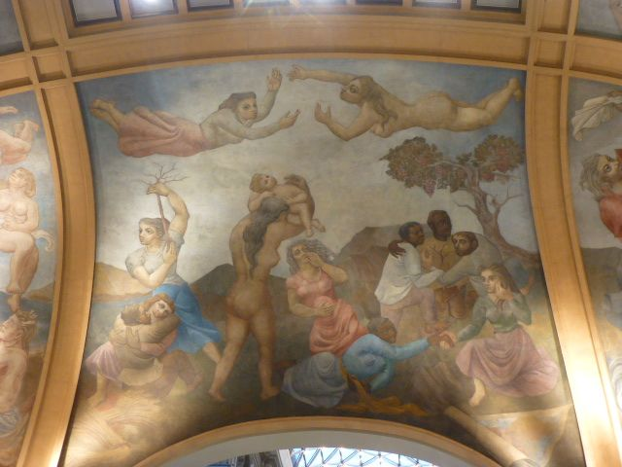

Urruchúa in collaboration with Taller de Arte Mural, *La fraternidad* (Fraternity). Fresco.1946. Galerías Pacífico. Photo credit: Caroline Olivia Wolf.

Urruchúa’s memoirs describe the concerns of the group to promote muralism in the country, and advocated their incorporation to young architects. While the Galerías Pacífico was the only realized collective work by the Taller Arte Mural as a whole, the artists would later split up to create further murals in smaller collaborations or independently. In 1956, Castagnino, Urruchúa and Policastro would receive a commission to create a mural cycle for the Galeria San José in the neighborhood of Flores in Buenos Aires, which would be similarly characterized by nationalist and local themes. Berni and Castagnino would continue to produce various murals independently, such as the murals executed for the Bingo 21 center in the neighboring city of Avellaneda.

As Adriana Pruzan has shown, the figurative language that dominates the Galerías Pacífico is ambiguous, evading direct symbolic interpretation while evoking a harmonious sense of cultural values. Overall the work of the Taller de Arte Mural is characterized by the concern to make allegorical art available to the public in their everyday environs.

**Bibliographic Sources:**

*Galerías Pacífico: Florida y Cordoba, Un lugar único en Buenos Aires.* Galerías Pacíifico S.A. : Buenos Aires, 1978.

Rafael Squirru, Julio Imbert, Flor Shapira Fridman. Translated by Harold Sinnott. *Galerías Pacífico; Berni, Castagnino, Colmiero, Spilimbergo, Urruchua. Murales de Buenos Aires (Murals of Buenos Aires).* Manrique Zago ediciones: Buenos Aires,1981.

Palomar, Francisco A. *First Art Salons in Buenos Aires*, Cuadernos de Buenos Aires, nº 18: Buenos Aires, 1972.

Pagano, José León. *El arte de los argentinos.* Buenos Aires, edición del autor, Volume 1. ,1937-1938.

Pruzan, Adriana. “Taller de arte murale: Obra realizada en Buenos Aires: Objectos y logros,” 267.

**List of Works by the Taller Arte de Mural:**

Mural cycle of the Galerias Pacifico, Buenos Aires, Argentina.

Individual panels in this mural cycle include:

Antonio Berni, *El Amor* [Love] or *La germinación de la tierra* ;

Juan Carlos Castagnino, *La vida doméstica* [Domestic Life] or *La ofrenda generosa de la Naturaleza* [Nature’s Generous Offering];

Manuel Colmiero, *La Pareja Humana* [The Human Couple] or *El amor maternal* [Maternal Love;

Lino Enea Spilimbergo, *El dominio de las fuerzas natural* (The dominion of natural forces);

Demetrio Urruchúa, *La fraternidad* (Fraternity)

1. Adriana Pruzan, “Taller de arte murale: Obra realizada en Buenos Aires: Objectos y logros,” 267.
2. Rafael Squirru, Julio Imbert, Flor Shapira Fridman. Translated by Harold Sinnott. *Galeria Pacifico; Berni, Castagnino, Colmiero, Spilimbergo, Urruchua. Murales de Buenos Aires (Murals of Buenos Aires).* Manrique Zago ediciones: Buenos Aires,1981; Palomar, Francisco A. *First Art Salons in Buenos Aires,* 1972.
3. Maria Cristina Serventi, “La vida domestica/ Como ver la obra” Arte Para Todos, *La Nacion*.